NOTES

Basic Git Commands

1. git init
2. git add<file name>



1. git commit -m “add the commit message ”



4. git status

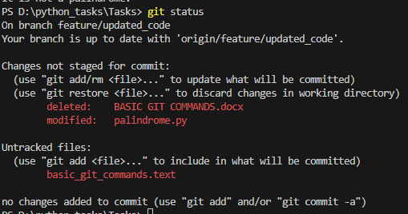

1. git log

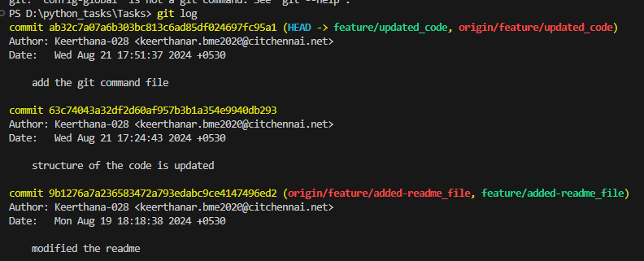

1. git push origin <origin name>
2. git config-global user. <Name>



1. git config-global user.email
2. git clone
3. git checkout



1. git merge<branch name>
2. git pull

**29.8.2024**

**BASIC LINUX COMMANDS**

1.mkdir python_project (used to create file)

2.rm python_project (remove files)

3.cp python.txt (copy the text)

4.mv python.txt \path (used to move the file to the desired path)

5.touch python.txt ( used to create a empty file)

6.cat python.txt (it will display the cotents of the file)

7.pwd (it is used to print the current working directory)

8.cd Tasks (it is used to change the working directory)

9.wget http/python.com.zip (used to download file from internet)

10.date (used to display the current date)

11.nano python.txt (it will open a text editor)

12.grep “pattern”python.txt (it is used to frind the specified pattern)

13.uname a (it will give thes system information)

**6.9.24**

**JSON File(javascript object notation)**

*Lightweight format for storing and transporting data.

*Used when data is sent from server to the web page.

JAON syntax

*Data is in name or value pair.

*It is separated by commas.

*Curly braces hold the object

*[] holds the array.

Javascript

*key can be string, number...

MODIFICATION: person.name= "keerthana"

Json files are in .json format.

JSON.parse(): it is used to convert the json into javascript.

Jquery Syntax

*jquery is used to make the javascript more easier and powerful.

Syntax:

1.$ = It is used to access the jquery.

2.Selector is used to find the html element.

3.action() is used to perform on the elements.

example:

1. $("p").hide() used to hide the all <p> element.

2. $(".test").hide() use to hide element with class test.

3. $("#test").hide() use to hide element with class test.

JQUERY EVENT METHODS

1. $(document).ready()= it allow us to execute the function only when the document is fully loaded.

2.click()= This will work only when the user click on the <P> element.

3.dbclick()= this is work when the use double click on the <P> element.

4.mouseenter()= It will show the alert message when we enter the specific mentioned element.

5.mouseleave()=It will show the alert message when we leave the specific mentioned element.

6.mousedown()=When mouse is being clicked left, right or middle part over the p element it will show alert message.

7.hover()= It is a combination of two when the mouseenter() and the mouseleave().

8.focus()= it is used to highlight the field when it is clicked.

9. on()= Attach one or more event handlers for the selected element.